
The Panther Post
South Smiths Station Elementary
SSS Supporting Student Success
From the desk of TC Phillips, Principal
FUNDRAISER
Thank you for supporting our fundraisers. Please help us reach our goal by encouraging friends and family to purchase chocolate bars. Your child will receive a flyer, on Monday, Jan. 10th with information about selling a box of chocolate bars. The candy bars sell for $1.00 each and the students will earn prizes as they sell. The deadline to turn in the money is Jan. 21st. We are hoping to buy playground shade structures with the money we raise. Our South Santa Night was a huge success. Special thanks to our PTO for organizing the fun event for our children and to those parents that came out and bid on the fabulous baskets the grade levels created.
WINTER COATS
We have a lost and found in our front office with lots of winter coats. We plan to donate these if they are not claimed by February. If your child is missing a coat, please come look through the collection in the office.
AFTER SCHOOL TUTORING
Mountain Movers Academy is sending new invitations. The new tutoring sessions will begin Wednesday, Jan. 19th. This is a free tutoring opportunity for students in Kindergarten-3rd grades. We are looking forward to working with your children. The academy will end @ 4:30. If your child is attending, please pick them up promptly at 4:30. If your child qualified to attend, they received an invitation. If your child attends our Academy, please join the REMIND link so you can receive any announcements throughout the year. The class name is Mountain Movers Academy and the class code is @f6ka9a
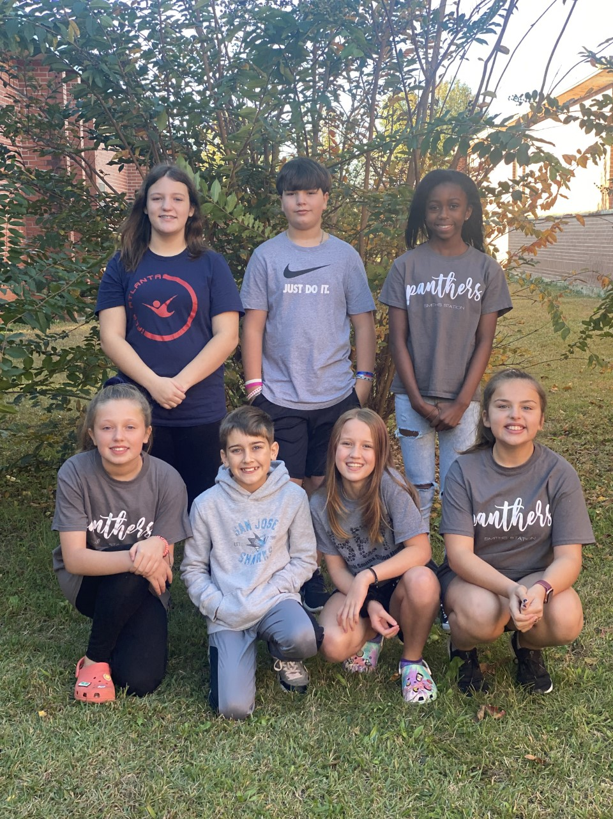
PANTHER NEWS TEAM
The Panther Paws News Team is new for South this year. It consists of a group of 6th grade students who are recording and editing news each week for the student body to watch. News includes, birthdays for the week, lunch, word of the month, 20-book challenge shout outs, what’s the scoop (special highlights and info for the week), and a variety of interviews/pictures of school activities and school functions.The Panther Paws Network is a great opportunity for students to practice necessary 21st Century Technology Skills by recording, editing & producing a news broadcast.
NO SCHOOL
- Monday, January 17, 2022 (MLK Jr. Day)
- Monday-Friday, March 21-25 (Spring Break)
- Friday, April 15, 2022 (No School)
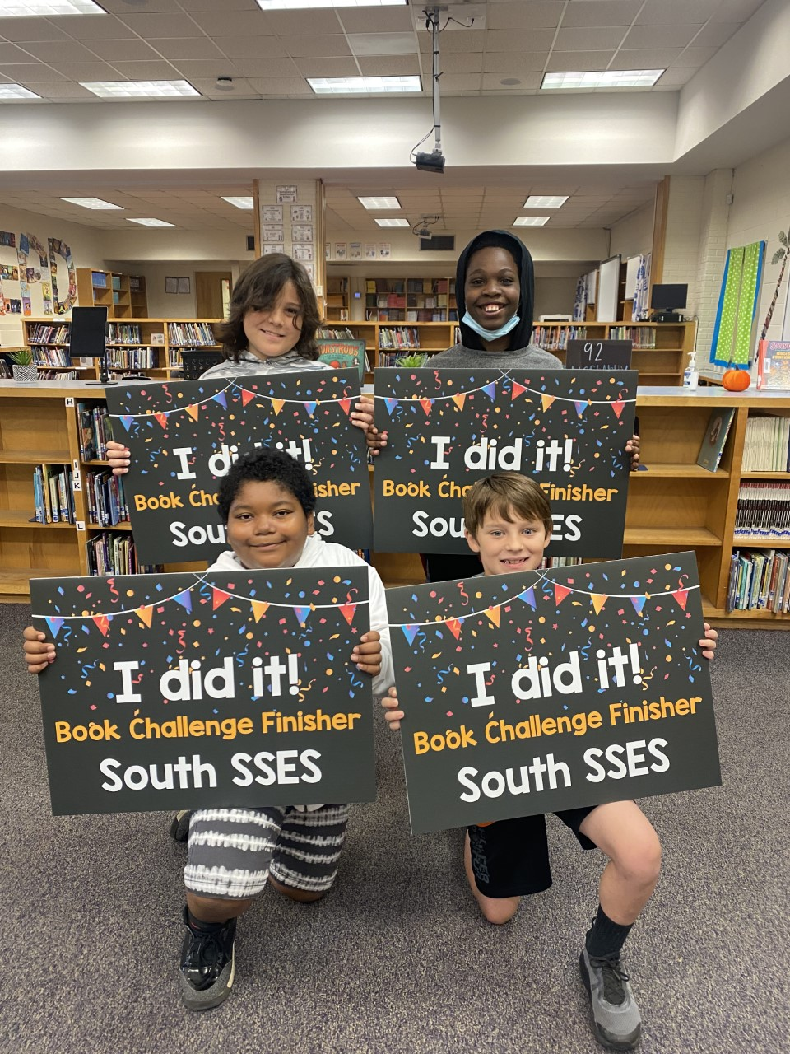
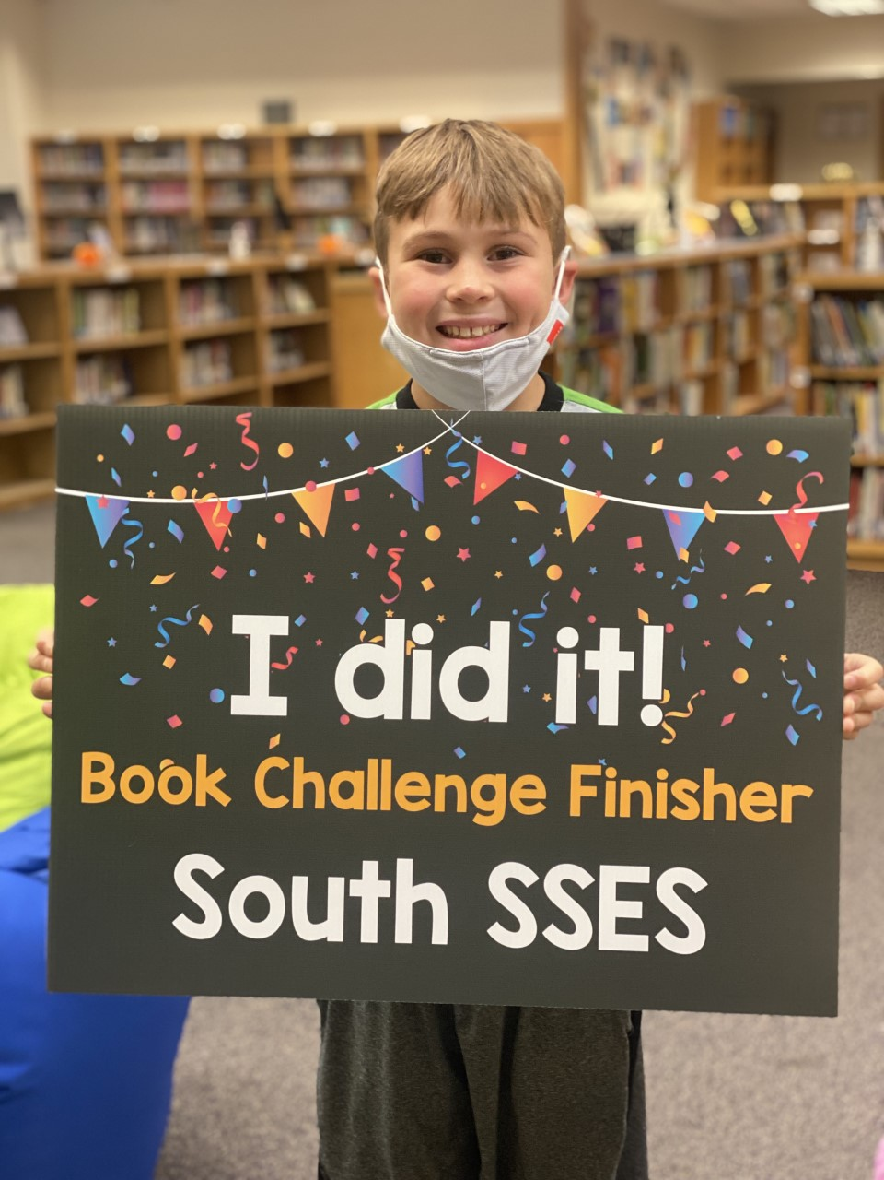
- Monday, April 18, 2022 (Employee Planning Day- No school for students)
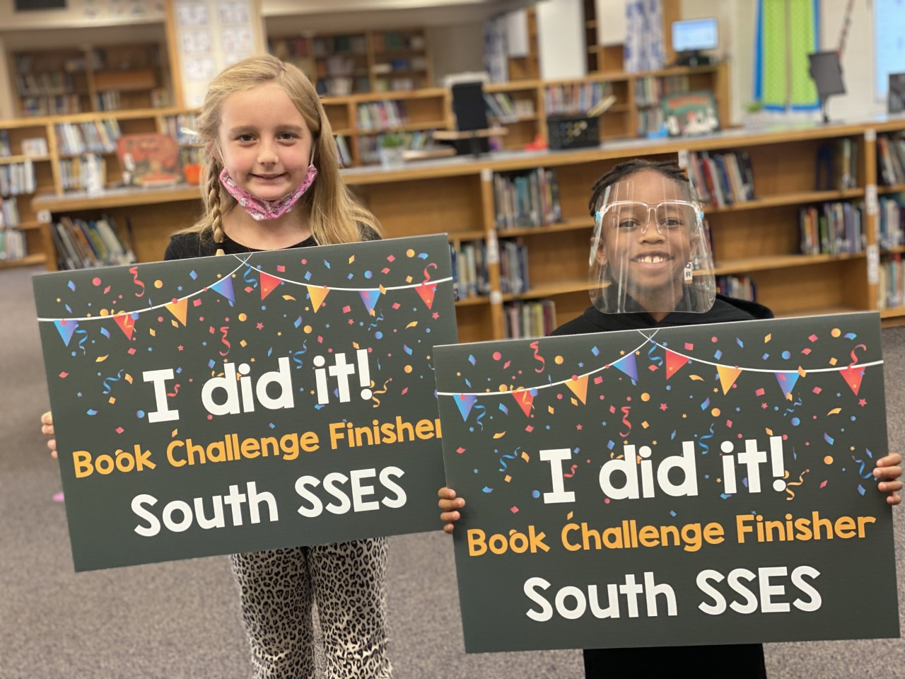
SSSES BOOK CHALLENGE
91 students so far this school year are meeting
the SSSES Book Challenge.

SPELLING BEE
Our annual Spelling Bee will be held Thursday, Jan. 13th @ 9:00 am cst in Building 1 - Extended Day Room.
REMINDERS
- Please continue to follow CDC and State guidelines for Covid 19. If your child is exhibiting signs of illness, please keep them home until well. Contact the school if your child tests positive or has contact with someone who tested positive for Covid 19.
- Parents must walk students into school when using the front parking lot. (We have no staff on duty in
that location- This is a SAFETY issue.)
- Remember to bring your photo ID to the front office to sign out your child.
- We are a smoke, tobacco, and vape free campus. Please do not smoke, vape, or use tobacco products on campus or while waiting for pick up in the car rider line.
- Please remember to check your child out prior to 2:00 CST as traffic, buses, and student movement creates congestion. Help us keep our students safe. Arrive before 2:00 CST.
- When using the car rider line, fill in the gaps between cars if you are first to arrive on campus. By creating a seamless line, we are able to move the line quickly and decrease the amount of time students have to sit and wait.

