
The Panther Post
South Smiths Station Elementary
SSS Supporting Student Success
From the desk of TC Phillips, Principal
YEARBOOKS
If you haven’t purchased your child’s yearbook, please come to the office and purchase one. They are in full color and the cost is $40.00. We have about 50 copies left.
FIELD DAY - May 11th
Concession Order forms went home Monday, April 25th to purchase pre-ordered snacks for field day. NO snacks will be sold the day of the event. Field Day will be held at the football stadium next to the Freshmen Center. Parking is available in the Freshmen Center Parking Lot. Parents may come to watch their child participate. Parents will be in the stands while students and teachers will be on the field. Schedules will be sent home by your child's teacher next week with specific times your child will participate.
AFTER SCHOOL TUTORING / SUMMER LITERACY
Mountain Movers Academy ended April 28th. Our school will take the end of the year Star assessment May 2nd (Reading) and May 3rd (Math). We are currently in the process of preparing for our Summer Literacy Camp. Be sure to return all summer learning letters for your child to participate this summer. We want to thank all of you for allowing us to work with your child this semester. With the hard work of our students and teachers, we are confident that we will see student growth. Contact your child’s teacher if you have any questions.
AWARD DAY - CELEBRATIONS
We will celebrate our students' academic accomplishments Monday, May 23rd and Tuesday, May 24th. The celebrations will be held at the Junior High Auditorium. Please plan to park at the ball fields and walk across the street. We will check ID’s at the table to enter. Please have your license out and ready to expedite the process.
Dates and Times: (Central Standard Time)
- Monday, May 23, 2022
  - 9:00-10:00- K-1st Grades
  - 10:30-11:30- 2nd-3rd Grades
  - 12:30-1:30- 4th-5th Grades
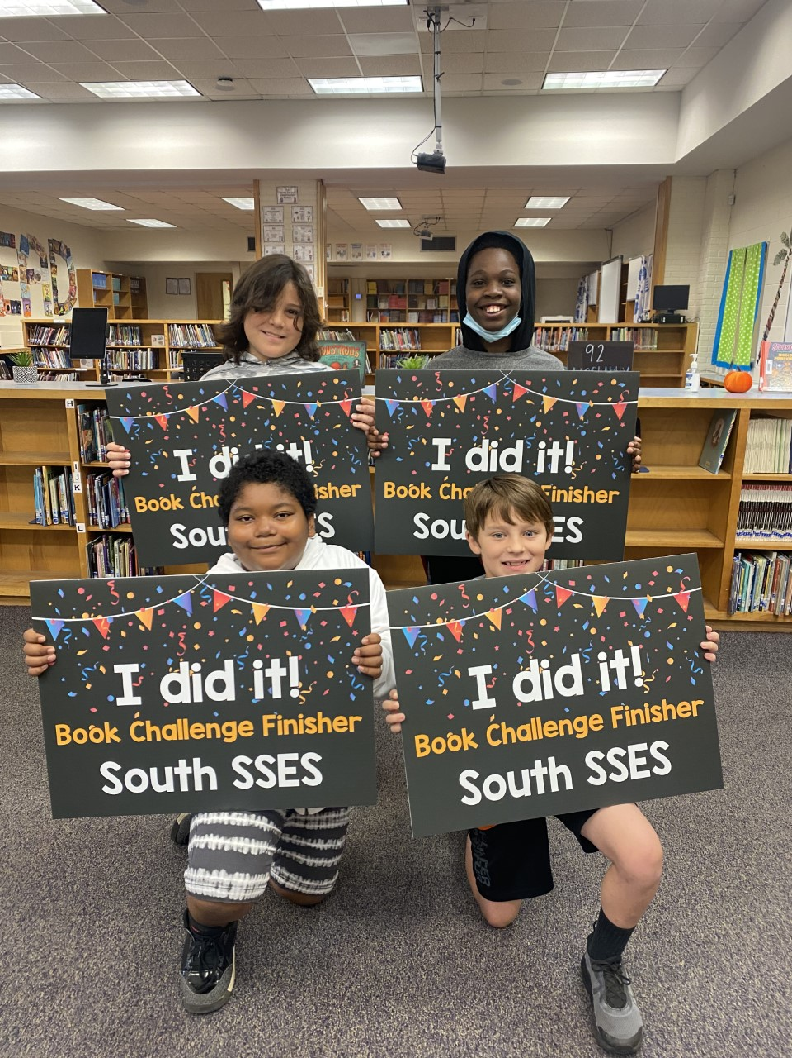
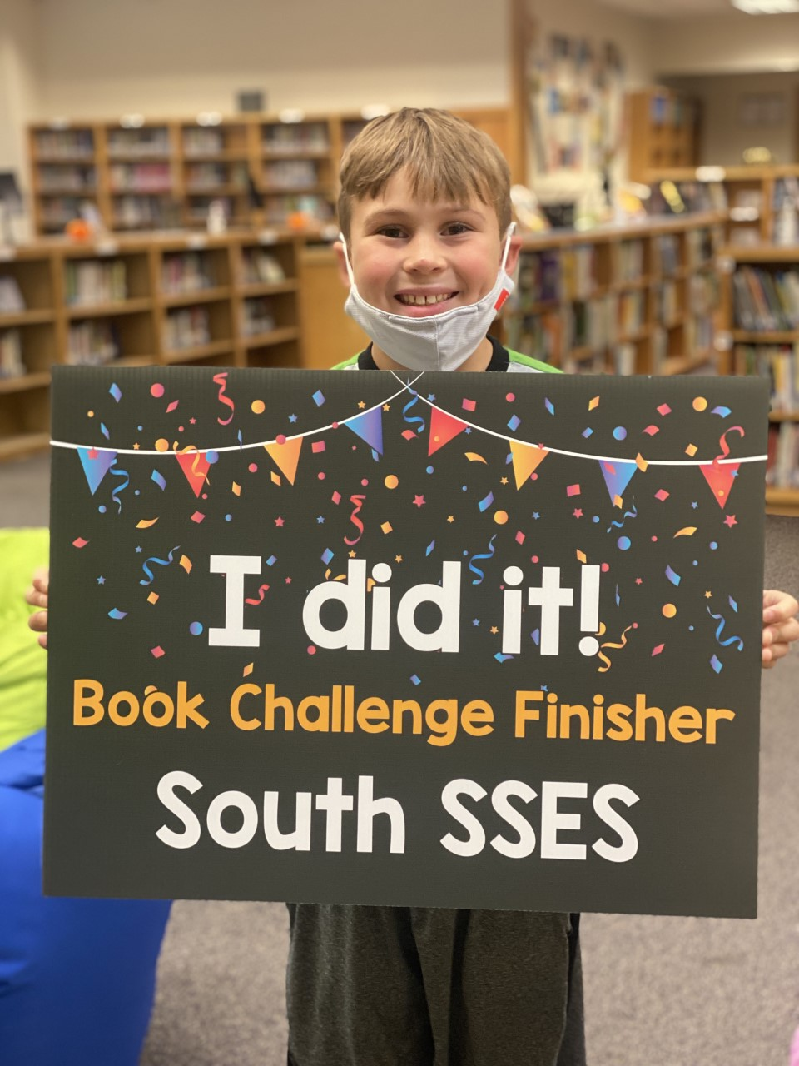
- Tuesday, May 24, 2022
  - 10:00-12:00 - 6th Grade Celebration
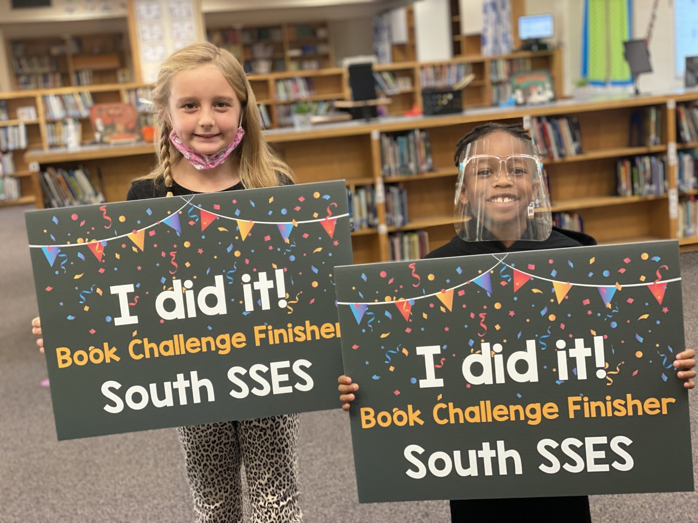
SSSES BOOK CHALLENGE
Our Book Challenge was a HUGE success. We had so
many kids meet their goal. We are so proud of their
hard work. Those that met the challenge will be
invited to attend a magic show this month. The Magic
Show will be this Thursday, May 5th.
REGISTRATION
If you have an upcoming Kindergarten student and you have not registered, please contact the office.
REMINDERS
- Parents must walk students into school when using the front parking lot. (We have no staff on duty in
that location- This is a SAFETY issue.)
- Remember to bring your photo ID to the front office to sign out your child.
- We are a smoke, tobacco, and vape free campus. Please do not smoke, vape, or use tobacco products on campus or while waiting for pick up in the car rider line.
- Please remember to check your child out prior to 2:00 CST as traffic, buses, and student movement creates congestion. Help us keep our students safe. Arrive before 2:00 CST.
- When using the car rider line, fill in the gaps between cars if you are first to arrive on campus. By creating a seamless line, we are able to move the line quickly and decrease the amount of time students have to sit and wait.
- May 2-6th is Teacher Appreciation Week. Please consider showing them love and support this week. A simple note of appreciation means the world to them.
THE LAST DAY OF SCHOOL: May 25th - Feel free to take pics with our Flip Flop Summer sign out front to celebrate your child’s last day of school.

