*Smiths Station High School*

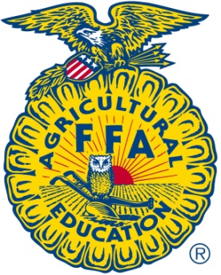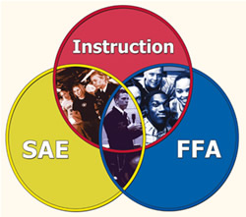

Agriscience Education

Course Syllabus

for

Forestry

Instructor – Mr. Duff

Instructional Philosophy:

Agriscience Education places a new emphasis on the integration of academics into existing agriculture/agriscience curricula, especially in the areas of science and mathematics. As a result of this emphasis, new programs are included in the Agriscience Education curriculum. This new direction serves two major purposes: (1) to provide students with the knowledge and skills needed to enter and advance in agricultural careers and (2) to enable students to function as informed citizens in today’s society. The Agriscience Education mission is to prepare students for successful careers and a lifetime of informed choices in the global agriculture, food, fiber, and natural resources systems.

Course Description:

Forestry is a course designed to enable students to become knowledgeable of forestry and wood technology. Students acquire an appreciation for increased emphasis on managing and conserving forest for the future. Topics include career opportunities, safety, history, dendrology, tree measurement, mapping silviculture, forest products, and forest protection.

Prerequisites: N/A

Career Technical Student Organization (CTSO): FFA

FFA is a dynamic youth organization that is an intra-curricular component of and agriscience program. FFA offers a variety of opportunities for members to get involved through leadership conferences, scholarship opportunities, and competitive events. The FFA Mission is to make a positive difference in the lives of young people by developing their potential for premier leadership, personal growth, and career success through agriscience education. To find out more about FFA, please visit www.alabamaffa.org or www.ffa.org.

Course Goals:

1. To provide education in and about forestry from the perspective of science and technology

2. To prepare students for employment in the forestry industry

3. To prepare students for entry into postsecondary programs in forestry fields

4. To provide education about the role of forestry in the conservation of the Earth’s natural resources

5. To develop life and employability skills essential for successful employment

6. To develop skills needed to fulfill occupational, social, and civic responsibilities

Grading Procedures:

All grades will be based on a 100-point scale and will be calculated using the following Category percentages:

* Test-50%
* Daily/Participation-20%
* Quiz/Project-30% (this includes SAE project)

It is important to understand that a large portion of the grade for this class will come from performance based activities. To be successful in this class students must participate in hands-on/lab activities. Students are expected to wear attire appropriate for construction related work. Students have the option to bring clothes to change into if they wish. Students that will not or cannot work due to their clothing or other reasons outside of valid doctor’s notes, will earn a ZERO for their daily grade and will not be given extensions on project deadlines.

Grading Scale:

A (90-100) B (80-89) C (70-79) D (60-69) F (<60)

\*\* Grades of .5 or greater will be rounded up; ex. (82.5 = 83)

Assessment Procedures:

1. Student notebook
2. Classwork/worksheets
3. Tests
4. Oral Written Reports
5. Construction relate performance task
6. Supervised Agricultural Experience (SAE) Project (this will equal 25% of their Semester grade)

Course Outline

1. Career opportunities in the Forestry Industry
2. Forestry Safety
3. The history of the Forestry Industry
4. Dendrology
5. Tree Measurement
6. Mapping
7. Silviculture
8. Forest products
9. Forest Protections

Materials Needed:

* 1 ½” Three ring binder dedicated to this class.
* Notebook dividers with tabs and pockets (at least 5)
* Paper
* Pens/pencils
* *Appropriate clothing/shoes for shop/construction work*

Course Length:

This course is a yearlong course and does count for (1) credit.

Class Fees/Dues:

The is no Fee for this class

FFA Dues are $12.00. FFA dues are optional yet high encouraged.

Available Credential(s):

NCCER Core Curriculum