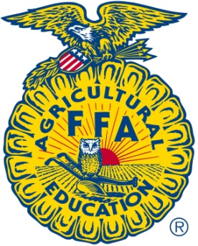Class Rules and Procedures

Agriscience Education

*Smiths Station High School*

*Mr. Duff*

Classroom/Shop Rules:

1. Be on time every day!
   1. We will be busy and will not have time to waste.
   2. You will be required to be at work on time so you need to get used to it!
2. Be Prepared
   1. Classroom: Paper, pen or pencil.
   2. Lab: proper clothing and closed toed shoes.
3. Be respectful of everyone.
   1. Teachers, staff, and classmates.
4. No food or drinks in the Shop area.
5. No Horse playing
6. Wear safety glasses at all times when we are in the shop.
7. Make safety your first priority!!!!!!!
8. Clean up after yourself

Classroom and Shop Procedures

1. Enter classroom quietly
2. Begin working on Bell Work
   1. We will have some form of bell work every day.
3. When you have completed the bell work place it aside and prepare for the day’s lesson.
   1. Classroom: have materials ready for notes or other class assignments
   2. Shop: insure that you are wearing proper clothing especially shoes.
4. Stay on task at all times.
5. Stop shop work immediately when instructed by teacher.
6. Ten minutes before the bell, we will begin cleanup procedures. Check the cleanup assignment chart for your duties for that day.
7. Always do your BEST work!

Consequences:

1. Student/teacher conference/FFA Creeds
2. Parental contact, after school/morning Detention
3. Office Referral

*If there is an issue concerning shop most importantly safety, the student may be set out of the shop with a written assignment for a period of one to two day are until they complete the written assignment.*