*Smiths Station High School*

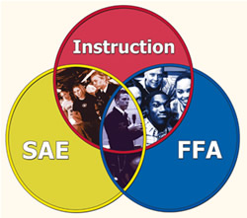

Agriscience Education

Instructor – Mr. Duff

Class Syllabus and Rules/Procedures

Signature form.

Parents and students,

This year I have posted a copy of each course syllabus along with the classroom rules and procedures on my faculty page. Therefore, you will not receive a printed copy.

These can be found in electronic form as follows:

* Go to my school webpage at <https://www.lee.k12.al.us/Page/3841>
  + Click the tab for your Course’s Resource Page on the left hand side of the page
    - Ex: Agriscience Course Resources
  + Open and review with your parents the Word Document File for your classes Syllabus and Rules.
  + Sign below after both documents have been reviewed and return this signature page to me.

I have reviewed the online syllabus for this course.

Parent’s Signature: ______________________________ Date___________________

Student’s Signature: _____________________________ Date___________________

I have read and reviewed the online version of the rules and procedures for Mr. Duff’s class.

Parent’s Signature: ______________________________ Date: ___________________

Student’s Signature: _____________________________ Date: ___________________